View from Zugspitze (2962m) to Titlis (3239m) - 207km:
Impact of Refraction Ritchie Sanden, Thomas May, Nov. 2007

Titlis in Switzerland is 3239m high, 207km away from Zugspitze and can be distinguished under optimal visibility towards WSW at about 250.4°. Here is an overview taken from Zugspitze East Summit in October 2005 towards Titlis:

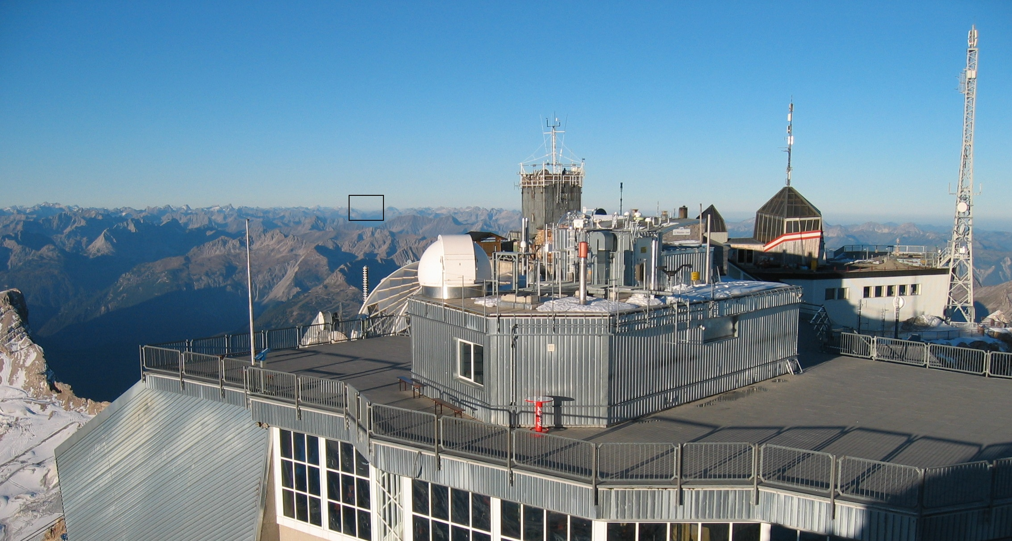

On 21st September 2007 Ritchie Sanden managed to take a photo of the summit of Titlis from Zugspitze. Equipment was Canon EOS 400D, 10,1 MPx, 300-Telelenses.
The small rectangle above shows the part shown below with some summits indicated:

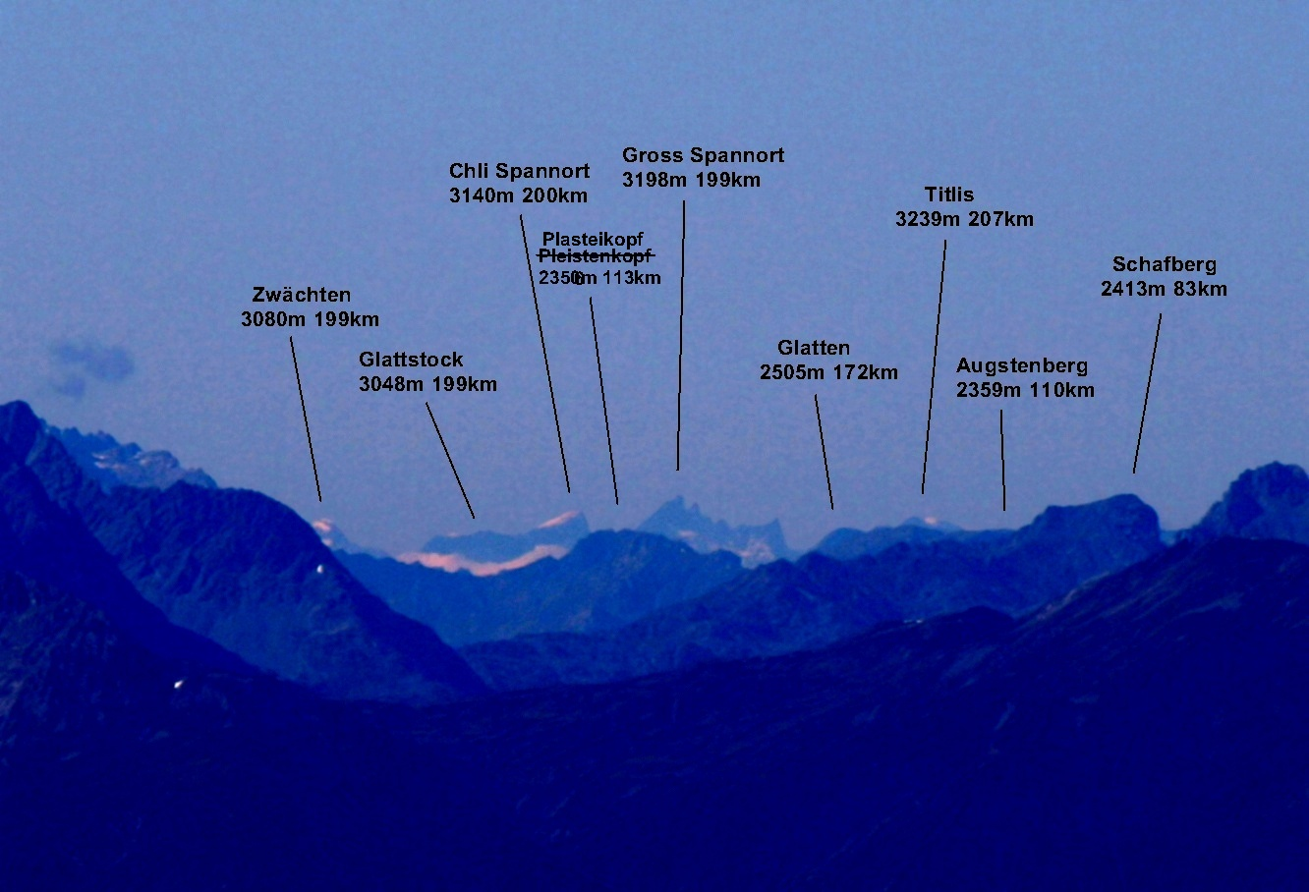

Titlis is nearly hidden behind the flat ridge of Augstenberg (2359m), which is 110km away.
We can estimate how much of Titlis summit is visible on the photo:
The horizontal angle between Gross Spannort and Zwächten is about 0.394°. Under the assumption that vertical and horizontal angles are not distorted, we can estimate, that Titlis summit is about 0.016° above the ridge of Augstenberg. In 207km distance, this corresponds to about 60 meters, so only the highest 60 meters of Titlis are visible. The summit of Augstenberg is slighly higher than the ridge, so Titlis passes it about 50 meters.

Titlis Summit is geometrically invisible from Zugspitze

Geometrically the drop of height of a mountain caused by earth curvature can be approached by: 0.0785 [m/km^2] d^2 (d is the distance in kilometers).
With this reduction, Augstenberg is 1410m high and Titlis –124m. You can calculate from this, that Titlis misses 165m to be seen behind Augstenberg. So geometrically Titlis is not visible from Zugspitze.

Observed Refraction is 14% of Earth Curvature - Titlis is visible

If we assume that Refraction is about 14% of Earth curvature, we get 0.0675 [m/km^2] d^2
as effective drop of height in this quadratic approximation.
With this reduction, Augstenberg is 1542m high and Titlis 347m. You can calculate from this, that the highest 57 meters of Titlis are visible, which corresponds to the above value extracted from the photo.
So with 14% Refraction, Titlis is visible as in above photo. It is highered about 220m with respect to Augstenberg and about 470m in total by Refraction, the Refraction Angle is 0.13°.

Double Check with Plasteikopf and Gross Spannort gives 12% Refraction

There is of course a incertainity on these estimations. So we have calculated the Refraction effect analog as above for the summits Plasteikopf (2356m, 113km) and Gross Spannort (3198m, 199km). Here we obtain a value of 12% for Refraction, which corresponds to an effective curvature of 0.0691 [m/km^2] d^2.

Discussion

The 2 values of 12% and 14% are quite close to the „classical“ Gaussian value of 13%. So this seems to be quite correct in this case. There is an uncertainity of about + / - 1% .
In other observations like from Munich Olympic Tower towards Grossglockner (150km) we have observed higher values for Refraction like 15% and 19%.

