Can the Malvern Hills be seen from Dunkery Beacon?

Since the nineteenth century, the Malvern Hills have been a popular tourist and walking destination. The main summit of the hills, Worcestershire Beacon, at 1394 feet above sea level, is the highest point of the county and thousands of people each year take in the stunning panoramic views from the hill. Worcestershire Beacon's landmark toposcope – one of the first in Britain – is popular among walkers identifying distant hills on the skyline as well as other landmarks. In recent years, digital tools have proven that the information given on the topscope is accurate regarding hills, towns and villages that have definitely been seen. However, a small number of hills are listed as either “cannot be seen or uncertain”. With the panorama generating software available in the twenty-first century, it is now possible to determine which hills in the “cannot be seen or uncertain” category are visible. One of these is Dunkery Beacon, almost eighty-five miles away in Exmoor National Park and in fact the highest point of Exmoor at 1705 feet above sea level.

Many guidebooks, some published in relatively recent years, claim that the Malvern Hills can be seen from Dunkery Beacon on a very clear day, although no Malvern guidebook to my knowledge refers to Dunkery as being visible from Worcestershire Beacon or any of the other Malvern Hills. Is there any evidence that, in certain weather conditions, Worcestershire Beacon and Dunkery Beacon are intervisible? This article will examine the numerous claims of a possible line of sight and find out in the light of new digital tools whether part of the Malvern Hills are indeed visible from Exmoor.

HOW FAR CAN BE SEEN FROM WORCESTERSHIRE BEACON?

One of the earliest references to the extensive view from Worcestershire Beacon is dated 1812. In this book, Letters of Malvern, the author makes a claim that King Road, a section of the Severn Estuary near Bristol Docks, is visible (Booker, 1812). In the same publication, the author also states “ in the clear north, where lie the Weavers and the Peak, is found a limit to the vision and a test of eyesight such as is afforded by few viewers in the kingdom”, Booker (1812, p.43). A General History of Malvern, published five years later, also refers to the “King Road or Bristol Channel” as being visible, although the writer mentions that King Road
is allegedly visible from “the Herefordshire side” (Chapman, 1817, p.28). The same book also contains a song discussing the view from the hills, by Joseph Bird, which contains the line (Bird in Chapman, 1817, p.279):

“On a clear summer's day, when the sky quite serene, the shipping in King's-road is plain to be seen”.

As well as the claim that King Road can be seen from the Malvern Hills, the song also contains the following line (Bird in Chapman, 1817. p.280):

“To the eastward we view Bosworth's gay plain, renowned by battle where King Richard was slain”.

No other references to Bosworth Field in Leicestershire being visible from Worcestershire Beacon appear. It appears possible that Bird could have applied some poetic license to his description of the landmarks visible from the Beacon. While many Georgian and Victorian writers clearly identified the counties close to the Malvern Hills, they were unsure as to which more distant counties were visible from the summit of Worcestershire Beacon. In 1822, however, a book by Mary Southall, A Description of Malvern and its Concomitants gave readers a detailed description of many of the hills, both near and distant that can be seen from Worcestershire Beacon. For the first time, a panoramic map was produced of the Worcestershire Beacon view. The description of the panorama refers to “The Estuary of the Severn” (Southall, 1822, p.100) as being visible, but makes no mention of Leicestershire. The Mendip Hills in Somerset are referred to as being visible as well as mountains in Rednorshire and Breconshire. The most distant point to the north listed as being visible is The Wrekin.

Southall (1822, p.7) also gives a detalied description of the view, stating :

“The prospects from these hills are amazingly extensive, bounded only by an uninterrrupted panoramic horizon. Upon the Worcestershire Beacon you may descry the counties of Monmouth, Hereford, Radnor, Brecknock, Salop, Worcester, Gloucester, the rivers Severn, Avon and the Teme; also the Bristol Channel. Encompassed by a lofty range of mountains, you see The Wrekin and Clee Hills in Shropshire, the Lickey Hill near Bromsgove, the Black Mountains in Brecknockshire, the hills in Abergavenny, the Gloucester hills an the Ledbury Mount, but to particularize all the delightful views which may be seen from the summits of the Malvern Hills, would exceed the limits of this small work.”

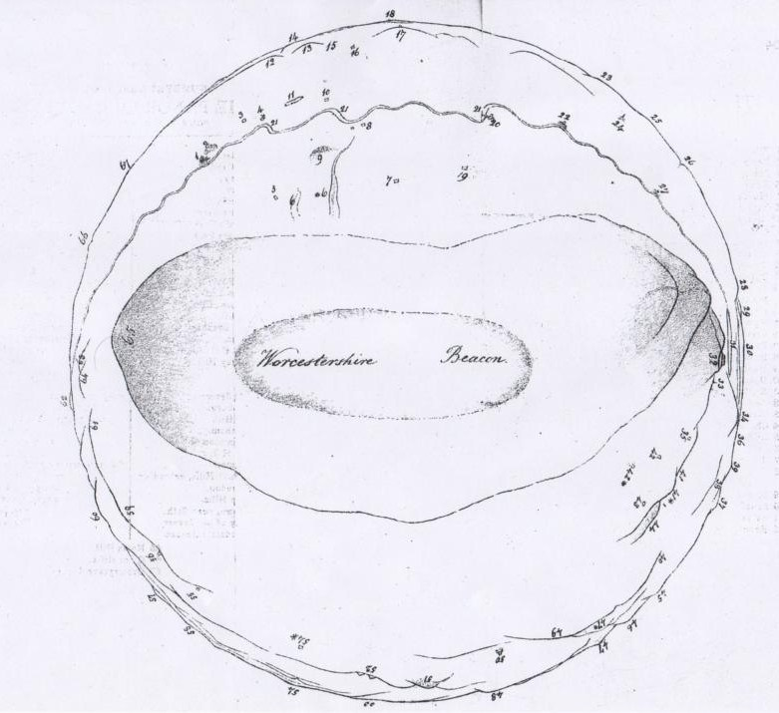
Mary Southall's 1822 panorama of the view from Worcestershire Beacon, the first panoramic diagram of the extensvie view.

Was Southall aware that there were more distant hills visible, and that she felt the description of which would take up too much space in her study of the views? After only eighteen years, another panoramic map of the Worcestershire Beacon view was published in H.W. Lamb's The Companion to the Worcestershire Beacon. Lamb listed eleven counties as being visible from the Beacon's summit – as well as including all of those previously listed by Southall in 1822, he mentions Oxfordshire, Warwickshire and Staffordshire (Lamb, 1840).

In 1858 a description of the Worcestershire Beacon view was published in a local guidebook, titled Malvern and its Environs, or a Handbook to Malvern. The author, J. Webster suggested that “possibly some high lands in...Wiltshire” (Webster, 1858, p.) can be seen from the Beacon. The claim that part of Wiltshire is visible is also made by Edwin Lees in Pictures of Nature in the Silurian Region Around The Malvern Hills and The Vale of Evesham. Lees commented on the distances he had observed from the Malverns' highest summit, referring to seeing over sixty miles. Lees went on to say (Lees, 1856, p,43) that “the Mendip Hills, seldom clearly discernible, may be as far, and perhaps some spot in Wiltshire”. Lees also mentioned in a footnote in the same publication that “I have read in some accounts of Wiltshire that the Malvern Hills may be seen from Alfred's Tower in that county”, Lees (1856, p.36).

1858 also saw the publication of a highly detailed study carried out by the Ordnance Survey, Account of the Observations and Calculations of Principal Triangulation. Military Officers of the Ordnance Survey all over the British Isles studied lines of sight, often those of considerable distance and recorded each hill or mountain on which the Survey had an observation station. The study of the view from Worcestershire Beacon confirms that the Mendip Hills in Somerset were visible, as well as Whitehorse Hill in Berkshire and Arbury Hill in Northamptonshire (Clarke, 1858). However, the Survey's observations from Bardon Hill in Leicestershire confirmed that Worcestershire Beacon is visible from the hill, giving the first recorded evidence that Leicestershire can be seen from the Beacon. However, no mention is made of any part of Wiltshire being visible.

In 1894, seventy-two years after the first panoramic map of the Worcestershire Beacon view, Malvern historian Charles F. Grindrod, who was well-known in the town as a doctor, wrote a detailed guide to the Malvern Hills and the town of Malvern, as well as the surrounding area. Grindrod (1894, p.32) gives a detailed description of the view, which turned out to be fairly accurate. “Roughly, the range is from the Wrekin in the north, to the Mendips in the south, and from Plynlimmon in the west to Bardon Hill in the east”. Grindrod also an interesting (and again fairly accurate) statement regarding how many counties are visible from Worcestershire Beacon, stating (Grindrod, 1894, p.32):

“the range of about fifteen counties of England and Wales many be set down as certain, and two or three others as doubtful. The certain ones are Worcester, Warwick, Gloucester, Somerset, Stafford, Oxford (allowing Edge Hill to be partly in that county), Leicester, Northampton, Hereford, Salop, Monmouth, Radnor, Brecon, Glamorgan and Montgomery. The uncertainties are Huntingdon, a slip of Devonshire...the Peak District in Derbyshire, a high point in Cheshire, and one or two other Welsh counties”.

Three years later, in 1897, Queen Victoria's Diamond Jubilee was celebrated with a huge bonfire on Worcestershire Beacon and it was decided that a toposcope should be erected on the summit. The toposcope, as previously mentioned, was one of the first in Britain and these circular maps identifying surrounding landscape features as well as towns and villages, originated in Switzerland (Squires, 2010). The designer of the Malvern toposcope was an architect from the town named Arthur Troyte Griffith who was friends with Worcester-born composer Sir Edward Elgar (Hurle, 1984). Elgar himself visited the hills regularly and in 1899 was living in Malvern Wells (Collett, 1981). It has also been said that the lofty summits were a source of inspiration for some of Elgar's works; while one of his Enigma Variations was in fact dedicated to Griffith (Cannadine, 2007). Although produced in honour of Queen Victoria's Diamond Jubilee, the toposcope was not unveiled until the summer of 1899. The highly detailed bronze disc became very well-known over the next few years, also featuring on a number of picture postcards (Squires, 2010).

Arthur Troyte Griffith's Worcestershire Beacon toposcope, which gave the most detailed description of the view from the Beacon.
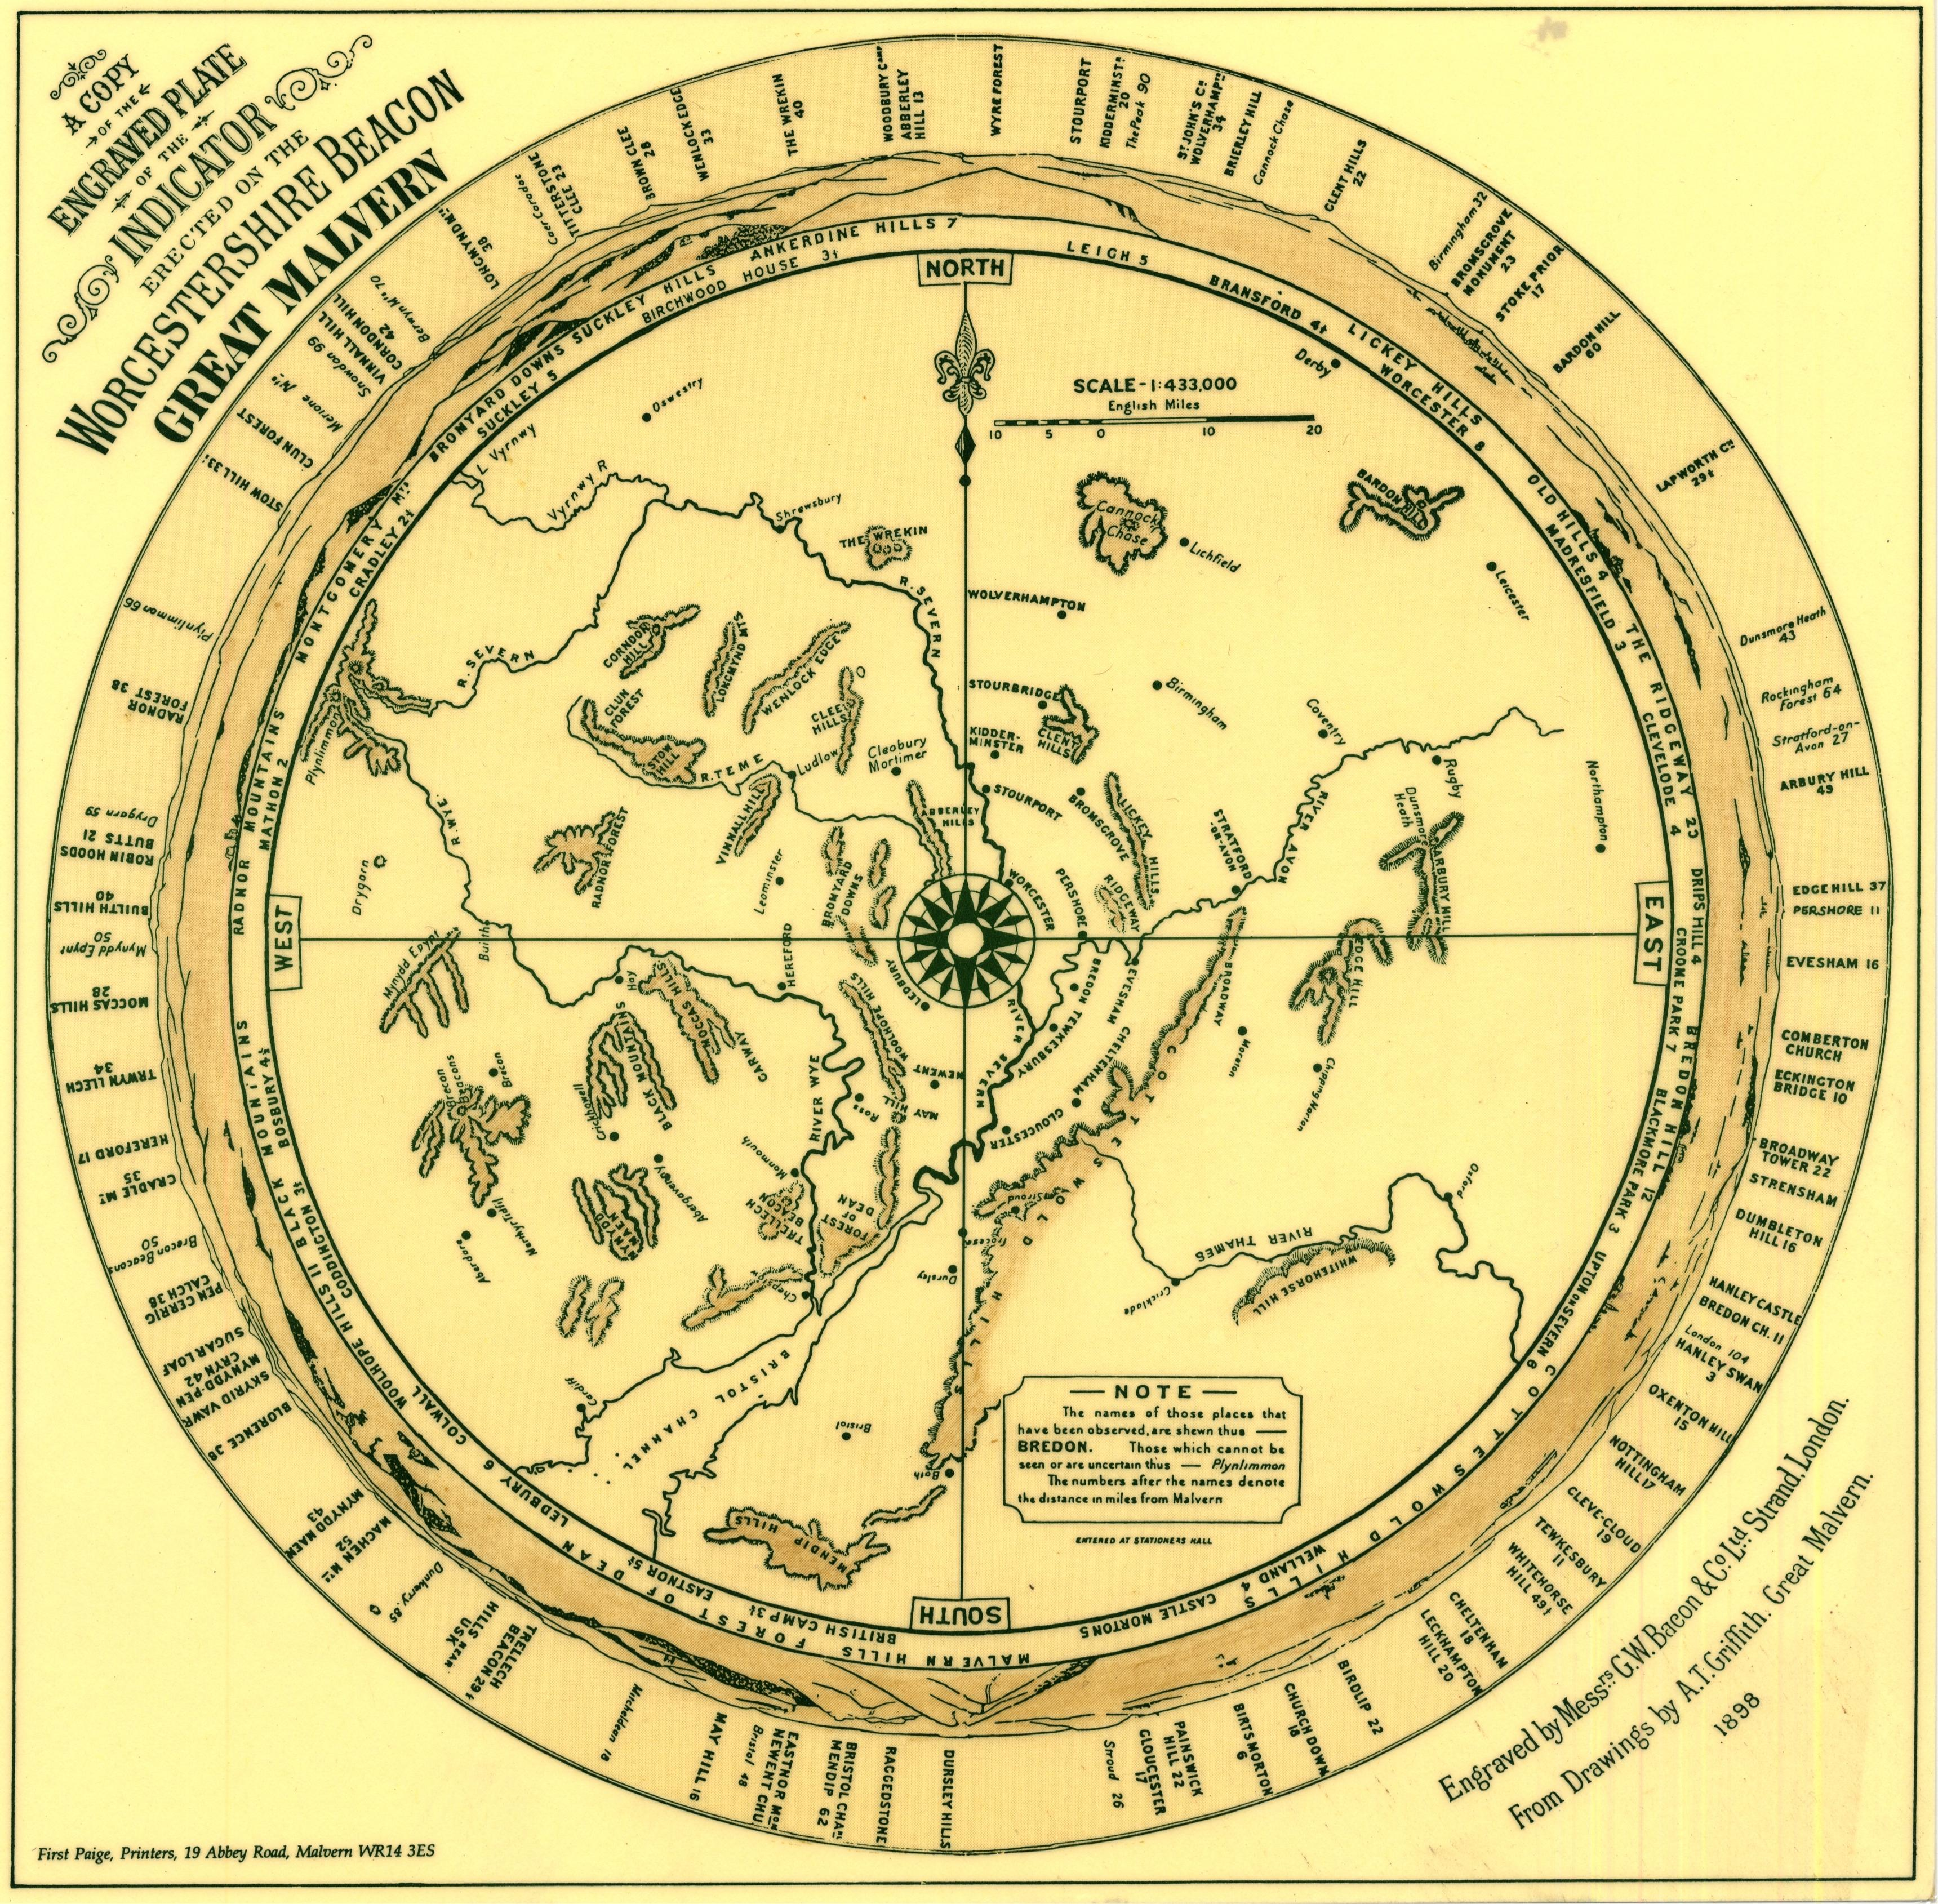

However, Griffith did not know the full extent of the Worcestershire Beacon view, or whether or not a few more distant landmarks were indeed visible. His note on the toposcope clearly states that places known to be visible are listed in capitals while places “that cannot be seen, or are uncertain”, in Griffith's words, are listed in italics. When examining the toposcope, it is clear that there are certain places that are obviously not visible, such as London, 104 miles and Rockingham Forest (East Northamptonshire, on low ground), 64 miles.

Listed in the same category is Snowdon, 99 miles. Other distant summits listed on the toposcope as uncertain also remained a mystery, especially as Griffith listed Plymlimon as one of these – Charles Grindrod had mentioned five years earlier that Plynlimon was visible. Other Welsh mountains in the “uncertain” category were the Berwyns (70 miles), the Merioneth Mountains (distance not given) and Mynydd Eppynt (50 miles). Also in the same category are the Brecon Beacons, although these towering summits definitely cannot be seen from the Beacon as their view is blocked by the Black Mountains; and The Peak (90 miles). As previously stated, Booker's Letters of Malvern (1812) suggests hills in this vicinity can be seen, although his reference does appear slightly vague – when mentioning “The Peak” (Booker, 1812, p.43) – was he describing the High Peak area, with the region's highest summits of Kinder Scout and Bleaklow, or was he simply referring to the Peak District hills in general, as Kinder Scout is actually 90 miles from Worcestershire Beacon?

Another distant hill on the toposcope added to the mystery of what can be seen in the distance. Yet another hill listed as “cannot be seen or uncertain” was Dunkery Beacon, the highest point of Exmoor, at nearly eighty-five miles. Despite these uncertainties, the toposcope was able to provide a highly accurate view, naming many hills, mountains, towns and villages that are indeed visible. It is notable that the name “Bristol Channel” appears on the toposcope, however - referring to the Severn Estuary. Although “Bristol Channel” is the name properly given to the stretch of sea flowing into the Atlantic, the name is often given to the mouth of the Severn. But in fact, only a broad, winding stretch of the Severn can be seen, for its estuary is clearly hidden from view by May Hill fifteen miles away, proving the claims regarding Kings Road or to give its more modern spelling of King Road, to be incorrect.

It was in the mid-1990s that topography expert Jonathan de Ferranti produced his first Viewfinder Panoramas. Computer technology had advanced to extent that it was now possible to produce a detailed view of every point visible from any summit all over the world. Ferranti's panoramas resulted in many unanswered questions being answered and the Viewfinder of Worcestershire Beacon was no exception to this. As well as showing the accuracy of the Malvern toposcope (for all the points Arthur Troyte Griffith listed as being seen also appear on the Ferranti Viewfinder), the panorama also shows that historian Charles Grindrod was correct – Plymlimon is visible 66 miles away. Also, a small part of the Berwyn range is visible, as well as part of Aran Fawddwy – one of the Merioneth mountains referred to, which is 74 miles from Worcestershire Beacon. However, the panorama reveals that Snowdon cannot be seen from the Beacon.

In more recent years, the website heywhatsthat.com has allowed any user to create a panorama. The panoramas differ from those of Jonathan de Ferranti in that the website also provides a map with a visibility cloak feature that enables users to find out exactly which areas would be seen from a summit on a clear day in conditions of normal refraction. The website also has a function that allows alteration of the refraction level to determine how much refraction is needed to allow a summit to be visible. When studying a Malvern panorama on heywhatsthat.com by utilising the visibility cloak, it is revealed that a small part of the Mynydd Eppynt range can be seen from Worcestershire Beacon. Although visible on the Ferranti panorama, the area of Mynydd Eppynt is not named.

However, Grindrod's suggestion that Glamorgan is visible turns out to be false, as the heywhatsthat visibility cloak shows no area within the county as visible. The old county of Huntingtonshire is also not visible from Worcestershire Beacon. Arthur Troyte Griffith was correct in his creation of the toposcope to include parts of the Peak District at 90 miles in the “cannot be seen or uncertain” category, for no part of Kinder Scout or any other hill in that particular area of the National Park is visible – the line of sight is totally obscured by more southern hills of the National Park. Booker (1812) made reference to the Weaver Hills, although these are also not visible.

The Viewfinder and heywhatsthat.com do show, however, that a range of hills in the western Peak District – Merryton Low, Axe Edge, The Roaches, Shining Tor and Shutlingsloe, are visible from the Beacon. It is possible that Booker saw these on a clear day and was uncertain as to which hills he was observing. Grindrod (1899, p.56) believed “somewhere to the north of Shrewsbury a point in Cheshire may be seen” and although no area of Cheshire is visible in this direction, the last two Peak District summits mentioned are within that county – Shining Tor being Cheshire's highest point. Slightly to the east of Shutlingsloe another hill of Cheshire just outside the boundaries of the Peak Distract National Park appears on the Viewfinder and heywhatsthat.com, this being one of the hills of Macclesfield Forest.

The claim that part of Wiltshire can be viewed from Worcestershire Beacon is confirmed as false by studying the Viewfinder Panorama and heywhatsthat.com. The long range of the Cotswolds blocks the view, a small part of Whitehorse Hill (recorded as visible on the toposcope) is the only area of a summit beyond the Cotswolds that can be seen. The area in which Alfred's Tower is located, close to the border with Somerset, is not visible and the visibility cloak of heywhatsthat reveals that the Malvern Hills are not visible from the tower. While Bardon Hill in Leicestershire is visible from the Beacon (it is also listed as visible on the toposcope), no other area of Leicestershire can be seen, proving that Bird's rather fanciful claim regarding Bosworth Field is also false.

By examining the towns and cities shown as “cannot be seen or uncertain”, two listed within this category are Coventry and Bristol. While no part of Coventry could be seen in the late nineteenth century in the present day a tower block on the outskirts of the city is clearly visible with binoculars. During one of my many visits to Worcestershire Beacon, I have noticed this block of flats clearly. Also appearing on the western edge of Coventry is the former office block of Massey Ferguson, a well-known tractor manufacturer. Sadly, this building is awaiting demolition at the time of writing. Although the centre of Bristol is not visible, heywhatsthat.com shows a few areas of the city to be visible – in the era before computers a very clear day and binoculars would have been needed to identify these areas. In particular, heywhatsthat reveals a few significant portions of the district of Soundwell as visible from the Beacon.

It can now be established how many historic counties are visible from Worcestershire Beacon, for heywhatsthat shows no other English and Welsh counties as visible in normal refractive conditions. Charles Grindrod's belief that fifteen counties was possibly true has persisted for many decades and it appears that many people generally believe that fifteen is the total number of counties that can be seen. For example, the Cotswold-info website states “it has been claimed that, at the summit of Worcestershire Beacon, 15 counties can be seen” (Anon, not dated) . An internet search revealed that the commonest claim in modern times is that fifteen counties are said to be visible. Some sources, however, suggest that only fourteen counties comprise the view – this total being included on a BBC Midlands Today website article discussing the Malvern Hills (BBC, 2009).

It can now be confirmed, by carefully studying both the Ferranti Viewfinder Panorama and heywhatsthat.com that the total number of historic English and Welsh counties visible from Worcestershire Beacon is nineteen. The “two or three doubtful” counties mentioned by Charles Grindrod could easily have been overlooked – it appears plausible that he might not have seen Aran Fawddwy (Merionethshire), Axe Edge (Derbyshire) and Whitehorse Hill (Berkshire). As previously stated, only a small part of Whitehorse Hill is visible, showing just above a slight dip in the Cotswolds near Cheltenham. While Grindrod (1894) recorded Oxfordshire as being one of the visible counties, he refers to certain areas of Edge Hill being within the county – the majority of the hill is located in Warwickshire. The Ferranti panorama and heywhatsthat.com also reveal an unnamed hill near the village of Sibford Ferris near Banbury as being visible. It is also worth noting that the small area of the Berwyn range visible from Worcestershire Beacon is located in Montgomeryshire – a much larger area of the range is within Denbighshire, but no part of Denbighshire can be seen from the Beacon. As only a small part of one of the Berwyn mountains can be seen, the range would have easily been overlooked by many people.

THE NINETEEN HISTORIC COUNTIES VISIBLE FROM WORCESTERSHIRE BEACON

Worcestershire | Bredon Hill, 12 miles
Warwickshire | Edge Hill, 38 miles
Gloucestershire | Cleeve Hill, 19 miles
Somerset | Black Down, 58 miles
Staffordshire | Turner's Hill, Rowley Regis, 30 miles
Oxfordshire | Hills near Sibford Ferris, near Banbury, 37 miles
Leicestershire | Bardon Hill, 60 miles
Northamptonshire | Arbury Hill, 49 miles
Herefordshire | Herefordshire Beacon, 4 miles
Shropshire | The Wrekin, 40 miles
Monmouthshire | Sugar Loaf, 35 miles
Breconshire | Hay Bluff, 33 miles
Radnorshire | Radnor Forest, 38 miles
Montgomeryshire | Corndon Hill, 43 miles
Cardiganshire | Plynlimon, 66 miles
Merionethshire | Aran Fawddwy, 74 miles
Berkshire | Whitehorse Hill, 49 miles
Derbyshire | Axe Edge, 80 miles
Cheshire | Shining Tor, 81 miles

WHAT WAS THE HILL CHARLES GRINDROD SAW?

The question still remains about Dunkery Beacon – displayed as uncertain, or possibly not visible on the 1899 toposcope. Ferranti's panorama shows clearly that the view towards Exmoor is blocked by the eastern slopes of Welsh Newton Common on the Herefordshire-Monmouthshire border. A study of the visibility cloak on heywhatsthat also reveals Dunkery not to be visible. But at least one Victorian publication refers to a sighting of a distant hill in the south-west. Charles Grindrod stated in the 1899 edition of Malvern: What to see and Where to Go that:

“When it is very clear another range can be seen south-west of these (The Mendips), doubtless the Quantock Hills of Somersetshire, with Will's Neck 1270 feet high. It is also possible, a Devon friend assured me...that it was a certainty, that part of Devonshire is visible beyond the Somersetshire hills, and, if so, this would be a high point of Exmoor” (Grindrod, 1899, p.44).

Jonathan de Ferranti's Viewfinder Panorama shows that neither the Quantocks or any area of Devon are visible from Worcestershire Beacon. No other guidebooks to my knowledge, as stated earlier, refer to Dunkery being seen from Worcestershire Beacon. But during the Nineteenth century a number of guidebooks to Exmoor in fact stated that the Malvern Hills could be spotted from the highest hill of what is now the National Park. It is this belief that will be investigated in the next section and research into the alleged Dunkery-Malvern line of sight will finally reveal if the old claim has any truth.

ARE THE MALVERN HILLS VISIBLE FROM DUNKERY BEACON – FACT OR FICTION?

The earliest known reference to the Malvern range being visible from Dunkery Beacon was recorded in Volume 13, Part 1 of the Beauties of England and Wales, or, Delineations, published in 1813. The authors stated (Britton and Brayley, 1813, p.558) that:

“In a clear day, the high lands near Plymouth, and the Malvern Hills, near Worcester, with all the intermediate scenery, comprehending a distance of two hundred miles, are distinctly visible”.

By 1856 at least one guide to England's West Country made a reference to the Malvern range as being visible from Dunkery. A Handbook for Travellers in Wiltshire, Dorsetshire and Somersetshire which was reprinted at least twice over the next twenty-six years contains the passage “on the summit (of Dunkery Beacon) are remains of the hearths in which beacon-fires were formerly kindled and which might have spread an alarm from the heights of Plymouth to those of the Malvern Hills, for both these points, although 200 miles apart, are visible from Dunkery on a clear day” (Anon, 1882, p.210). This later edition clearly has the same information contained in previous editions, reinforcing visitors to Dunkery to believe that on a clear day they could see the Malvern Hills over eighty miles away to the north-east.

As highlighted in the previous paragraph, beacon fires were once lit on Dunkery, giving the hill its present name. Worcestershire Beacon's name, of course, originated for exactly the same reason. Fires burned as warning signals could be seen from both Malvern and Exmoor at considerable distances. However, would a blazing beacon fire on Worcestershire Beacon on a very clear night be seen from Dunkery? It is not known whether, in exceptional conditions, a beacon fire may have been visible on Malvern's highest point at a distance of nearly 85 miles from Dunkery. It may have been possible, though, that light from a beacon fire on Dunkery was seen from Malvern at some point over the last few centuries (and vice versa) perhaps due to the fact that the highest summits of both areas are historically beacon hills where a fire on one could have been viewed from the other.

In fact, on 10th January 1856, a beacon fire lit at Malvern was documented in The Illustrated London News, with comments regarding the fire originally published in this newspaper later being published in the 1858 edition of Notes and Queries. One reader emphasised strongly that light from this beacon could not be seen at great distances, stating (Notes and Queries, 1858, p.55):

“From many places in the immediate vicinity of Malvern the bonfire was altogether invisible. Thus at Worcester, says one of the local papers, ...”no beacon glare rewarded their perseverance...generally the disgusted crowd drew off”...At nine o'clock on that evening I joined some friends who had posted themselves on an eleigible situation only three miles from Malvern, and who had not been favoured with a glimpse of the beacon; nor was it visbile from another point, distant five miles from Malvern”.

The reader also makes a point fo the reports that light from the Malvern beacon had actually been seen at great distances. Notably, a report from The British Meterological Society eleven days after the bonfire which quoted in the same letter mentioned (Notes and Queries, 1858, p.55):

“The Malvern light on the 10th inst. was distinctly seen from the beacon-hill, in the range of the Chilterns, at Chequers Court, near Aylesbury – being about 700 feet above the sea-level, and nearly seventy miles from Malvern. The fire had the appearance of a comet lying on the horizon, and having a tolerably bright centre – surrounded by a nebulous haze”.

Despite the inconclusive evidence that the fire of January 1856 was not seen at long distances, it is certainly possible that beacon fires on other hills on exceptionally clear nights could have been seen at a considerable distance, The same edition of Notes and Queries mentions a document from The Royal Engineers Corps dated 1842, which mentions (Notes and Queries, 1858, p.93):

“The heliostadt invented by Col. Colby, R.E., 4 or 5 in. in diameter, was used success at distances exceeding 100 miles from Prescelly, South Wales to Kippera, Wicklow; and from the Keeper, Tipperary, to Culcagh, Fermanagh”.

Although light from a heliostadt, or to give its more modern-day spelling of heliostat, could be observed at a long distance in daylight, there is no direct evidence of how far light from a bonfire on Worcestershire Beacon could be seen. Given the brightness of the fire observed on the Chilterns, it seems possible that observers mistook a much nearer fire for the Malvern beacon. It is conceivable, though, that light from a bonfire on Worcestershire Beacon may have been observed from Dunkery Beacon at some point. This could be a factor in the claim that the Malvern Hills themselves are visible from Dunkery, rather than simply light from a beacon.

Returning to computer-generated panoramas, the Ferranti Viewfinder of Dunkery Beacon no part of Worcestershire Beacon or any of the other Malvern Hills are seen. When studying the visibility cloak of the heywhatsthat Dunkery panorama, no part of the Malvern Hills appear visible either. A factor that must be considered, however, is variation of atmospheric refraction, as light travels from one point to another. Weather conditions are an important factor in determining how far can be seen. Exceptional weather conditions can cause the horizon to be stretched further, allowing certain summits to be visible that are geometrically below the horizon.

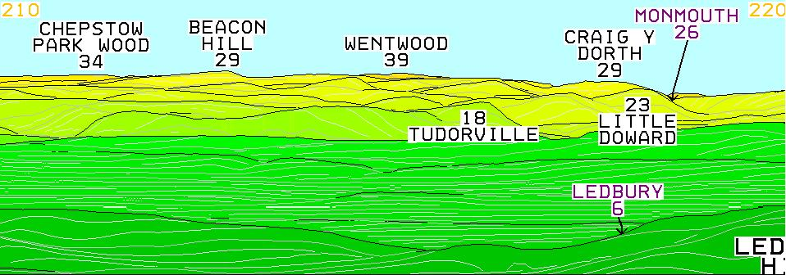
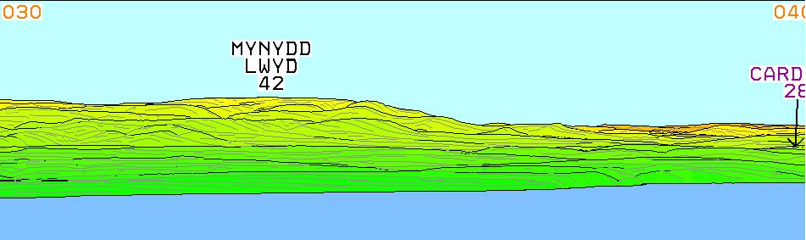
The Ferranti panorama showing the view from Worcestershire The Ferranti panorama showing the Dunkery Beacon view.
Beacon. Dunkery Beacon should appear at 219º. Worcestershire Beacon should appear at 39º.

Jonathan de Ferranti notes variation within atmospheric refraction on his website and both the Ferranti Viewfinders and the visibility cloak of heywhatsthat.com take refraction differences into account. Studies of views have discussed varying levels of refraction, such as Thomas May's 2007 study of the view to Grossglockner in the Austrian Alps from the Olympic Tower at Munich – Grossglockner is only visible in certain weather conditions due to the presence of a nearer summit in front (May, 2007). Topographer and author Chris Jesty notes a similar factor in the distant line of sight from Snowdon to mountains in Southern Scotland (incidentally the longest line of sight in the British Isles), stating “if it were not for the curvature of light passing through the atmosphere, Scotland would be completely hidden by the sea” (Jesty, 1980).

Clearly, normal atmospheric conditions will not bring Worcestershire Beacon into view from Dunkery Beacon. Despite this, higher than average refraction may be a key factor in allowing a distant part of Worcestershire to be seen from Exmoor. Squires (2010) notes the variation in refraction in refraction levels in nineteenth century Ordnance Survey studies, such as Clarke's research already referred to, as well as the study by Mudge et al in 1801, while Ferranti, on his website, clearly states “in special conditions, e.g. temperature inversions, features not shown on the panoramas may be visible”.

The Ferranti Viewfinders take atmospheric refraction into account and each panorama shows a view of all points that would be seen on a very clear day in normal conditions of refraction. The extent of refraction
can be measured by the so-called refraction coefficient (Clarke, 1858). The panoramas created by Jonathan de Ferranti display the view on a clear day with the refraction coefficient of 0.17%. Heywhatsthat includes a feature in which refraction levels can be entered and any level can be used once a panorama had been created. When drawing a line of sight between Dunkery and Malvern on heywhatsthat and applying 17% refraction, the view to Worcestershire is still blocked – proving the accuracy of the Ferranti panorama.

Thomas May, in his study of the line of sight, found that 18% refraction would be needed to see a small part of the top of Dunkery Beacon from Worcestershire Beacon. This study was carried out using a panorama generating website created by Dr. Ulrich Deuschle. This website - udeuschle.de - also allows the creation of panoramas, but unlike heywhatsthat, can calculate a panorama similar to those of Jonathan de Ferranti. Not only does a Malvern panorama elevated to take in effects of higher than average refraction show only a small area of Dunkery visible behind the eastern slopes of Welsh Newton Common, but an elevated panorama from Dunkery also shows only a small area of the top of Worcestershire Beacon to be seen.

However, this is too small and indistinct to generally be recognised as part of the Malvern Hills. Dunkery would clearly also appear indistinct when viewed from Malvern – simply resembling a distant area of high ground – this description applies even more to the small part of Worcestershire Beacon that would be seen from Dunkery in higher than average refractive conditions. It would, in fact, only be possible to identify Malvern from Dunkery (and vice versa) with binoculars or a telescope.

It is worth noting that the Dunkery Beacon toposcope, dating from far more recently that its Malvern Hills counterpart, mentioned on the Geograph.org.uk website as being erected in 1970, makes no mention of the lofty Worcestershire Hills, or more precisely their highest summit (Flickr, 2009). With a view to a small area of Worcestershire Beacon now confirmed as being a rare occurrence from Dunkery – and something that would only occur in exceptional, higher than average conditions of refraction – it now sounds possible that a person or persons saw other distant hills from Dunkery and mistook them for the Malvern range. In fact, Jonathan de Ferranti has mentioned that the two hills would be intervisible “on really clear still mornings and evenings, when refraction tends to be higher” (Ferranti, 2011). It is clear, then, that these conditions refrerred to by Ferranti, as well a temperature inversions, would be the only factors to produce a refraction coefficient higher than average.

A CASE OF A MISTAKEN HILL?

The Ferranti Viewfinder Panorama of Dunkery Beacon shows a group of hills to the north-east around sixty miles away, which are located on the Herefordshire-Monmouthshire border. One prominent hill in this direction, Little Doward, located at approximately 41 degrees – and close to Welsh Newton Common which is the hill blocking Dunkery from the Malvern Hills in conditions of normal refraction – would appear as a distinct, hump-shaped steep hill when viewed from Dunkery. Although not strongly resembling the Malvern Hills when viewed at closer distances, at a distance of around 60 miles, Worcestershire Beacon would appear similar to Little Doward. Could it be possible, therefore, that Little Doward was mistaken for part of the Malvern Hills in the eighteenth or early nineteenth century? It appears that the shape of the hill could have fooled visitors to Dunkery who could have also examined the hill more closely by telescope. It seems possible that distance might not have been taken into account and that the distant blue-grey shape of Little Doward at around 60 miles was wrongly believed to be the higher summits of the Malvern Hills, therefore leading to the belief that the Malvern range can be seen from Dunkery Beacon in normal weather conditions.

From the above evidence, it seems even more plausible that the shape of Little Doward, 62 miles from Dunkery Beacon was mistaken, probably on a number of occasions, for Worcestershire Beacon. Maybe some of the people who wrongly identified the hill had also seen Worcestershire Beacon from other location – maybe he or she was a well travelled person who had not fully taken distance into account. Although it is possible, with refraction slightly higher than average, for part of Worcestershire Beacon - but none of the other Malvern Hills - to be seen from Dunkery Beacon (and vice versa), the various guidebooks appear to state that the Malvern Hills would be visible from Dunkery on any clear day in normal conditions. It appears, therefore, that the belief of Worcestershire Beacon being seen from the highest point of Exmoor on any normal, very clear day, appears to be the result of another hill being mistaken for part of the Malverns, as research appears to suggest. No publications refer to either a definate sighting of Worcestershire Beacon from Dunkery Beacon or Dunkery Beacon from Worcestershire Beacon. Although, as stated, higher that average conditions will bring a small part of the Malvern Hills' highest point into view from Dunkery, it is very doubtful that the small area visible would be recognised as Worcestershire Beacon.

CONCLUSION

The extensive views from many hills throughout the British Isles have long been the subject of many books and articles and in the age before digital technology, the extent of a view could not always be decided, and many claims arose that in recent years have turned about to be untrue. What we now know as incorrect information regarding which summits can or cannot be seen from a hill or mountain has continued to remain in print for decades. However, with twenty-first century computer technology it is now possible to determine how far a summit's view stretches and which land features are visible, finally answering the many questions that hill walkers have debated for close to two centuries. Research using panoramic software has proven that Dunkery Beacon and Worcestershire Beacon are not intervisible in normal refractive conditions and that only in fairly rare, higher than average conditions can a small area of one be seen from the other and then only with optical aid.

REFERENCES

ALLEN, KEVIN (1997) Elgar: The Cyclist in Worcester and Hereford: A Creative Odyssey. Malvern: Aldine Press Limited

ANON (1858) Notes and Queries: Second Series – Volume Fifth. London: Bell & Daldy

ANON (1869) A Handbook for Travellers in Wiltshire, Somersetshire and Dorsetshire. London: John Murray

ANON (2009) Worcestershire Beacon, Malvern Hills. [online] [accessed 20 December 2010] Available at <www.bbc.co.uk/midlandstoday/content/articles/2009/01/12/malvern_hill_12019_feature.shtml

ANON (Not Dated) The Malvern Hills Tourist Information and Travel Guide. [online] [accesed 20 December 2010] Available at <www.cotswolds.info/worcestershire/the-malverns.shtml>

BIRD, JOSEPH (1817) Malvern Hills: A New Song by Joseph Bird. From a Broadside Ballad Printed and Sold by J. Grundy, Friars Street, Worcester in CHAMBERS, JOHN (1817) A General History of Malvern. Worcester: William Walcott, pp.279-280

BOOKER, LUKE (1812) Letters of Malvern, Descriptive and Historical: Containing also an account of its waters and accommodation. Worcester: J.R. Hunt

BRITTON, JOHN AND BRAYLEY, EDWARD WAYLAKE (1813) The Beauties of England and Wales, or Delineations. Topgraphical, Historic and Descriptive. Volume 13, Part 1. London: J. Harris

CANNADINE, DAVID (2007) Orchestrating his own life: Sir Edward Elgar as a Historical Personality in Elgar – An Aniversary Portrait Introduced by Nicholas Kenyon. London, New York: Continuum

CHAMBERS, JOHN (1817) A General History of Malvern. Worcester: William Walcott

CLARKE, ALEXANDER ROSS (1858) Account of the Observations and Calculations of Principal Triangulation. London: George Edward Eyre and William Spottiswoode

COLLETT, PAULINE (1981) Elgar Lived Here. London: Thomas Publishing

DE FERRANTI, JONATHAN (Date Unkown) Longest Lines of Sight [online] [accessed 18 December 2010]
Available at <www.viewfinderpanoramas.org>

DE FERRANTI, JONATHAN Email to M. Mills, 1 April 2011

EARLE, JOHN (1991) Exmoor and the Quantocks: A Walker's Guide. Milnthorpe, Cumbria: Cicerone Press

FLICKR (User's full name not known) (2009) DSCF3425 (Photograph of Dunkery Beacon Toposcope) [online] [Accessed 21 December 2010] Available at <http:www.flickr.com>

GEOGRAPH BRITAIN AND IRELAND (Website) Available at <http://www.geograph.org.uk>

GRINDROD, CHARLES F. (1894) Malvern: What to See and Where to Go. Malvern: John Thompson

GRINDROD, CHARLES F. (1899) Malvern: What to See and Where to Go. Malvern: John Thompson

HARPER, DEREK (2009) Toposcope, Dunkery Beacon [online] [Acessed 12 April 2011] Available at <http:www.geograph.org>

HEYWHATSTHAT (Website) Available at <http.www.heywhatsthat.com>

HURLE, PAMELA (1984) The Malvern Hills: A Century of Conservation. Chichester: Phillimore & Co. Limited

JESTY, CHRIS (1980) A Guide to the view from the summit of Snowdon. [online] Bridport, Dorset: Jesty's Panoramas [accessed 18 Decmber 2010] Available at <www.viewfinderpanoramas.org>

LEES, EDWIN (1856) Pictures of nature in the Silurian Range around the Malvern Hills and Vale of Evesham. Malvern, H.W. Lamb

MAY, THOMAS (2007) View from Munich Olympia Tower to Grossglockner: Impact of Refraction [online]
[accesssed 18 December 2010] Available at <www.viewfinderpanoramas.org>

MAY, THOMAS (2010) Email to M. Mills, 25 November 2010

MAY, THOMAS (2010) Email to M. Mills, 23 December 2010

MUDGE, WILLIAM, DALBY, ISAAC AND COLBY, THOMAS (1801) An Account of the Operation Carried out for accomplishing a trigonometrical survey of England and Wales, Vol. 2 in in SQUIRES, DAVID (2010) Can Snowdon be seen from The Wrekin? A Topgraphic Detective Story Proceedings of the Cotteswold Naturalists' Field Club XLV (I), 2010, p.72 [online] [accessed 6 March 2010] Available at: <www.viewfinderpanoramas.org>

ROYAL ENGINEERS CORPS PAPERS (1842) in ANON (1858) Notes and Queries: Second Series – Volume Fifth. London: Bell & Daldy, p.93

SNELL, FREDERICK JOHN (1906) The Blackmore Country. London: A. and C. Black

SOUTHALL, MARY (1822) A Description of Malvern and its Concomitants; Including a Guide to the Drives, Rides, Walks and Excursions; With a Map of the Walks; A Panoramic Sketch of Objects from the Worcestershire Beacon, And Other Embellisments. Stourport: G. Nicholson

SQUIRES, DAVID (2010) Can Snowdon be seen from The Wrekin? A Topgraphic Detective Story Proceedings of the Cotteswold Naturalists' Field Club XLV (I), 2010 [online] [accessed 6 March 2010] Available at: <www.viewfinderpanoramas.org>

SQUIRES, DAVID (2010) Email to M. Mills, 29 August 2010

SQUIRES, DAVID (2010) Email to M. Mills, 11 November 2010

VIRTUELLE PANORAMATAFELN (Website) Available at <www.udeuschle.de>

WEBSTER, J. (1858) Malvern and Its Environs, or a Handbook to Malvern. Malvern: Thomas Hartley

With thanks to Thomas May, David Squires, Jonathan de Ferranti, Ulrich Deuschle, Malvern Library, the staff at First Paige, Malvern and Prontaprint, Dudley.

